**EXP NO 11: CREATE A HARD DISK**

**Aim:**

**Creating a new hard disk compatibility of a VM using Virtual box.**

**Materials:**

* **Virtual box**
* **Data**

**Procedure:**

**Step 1:**

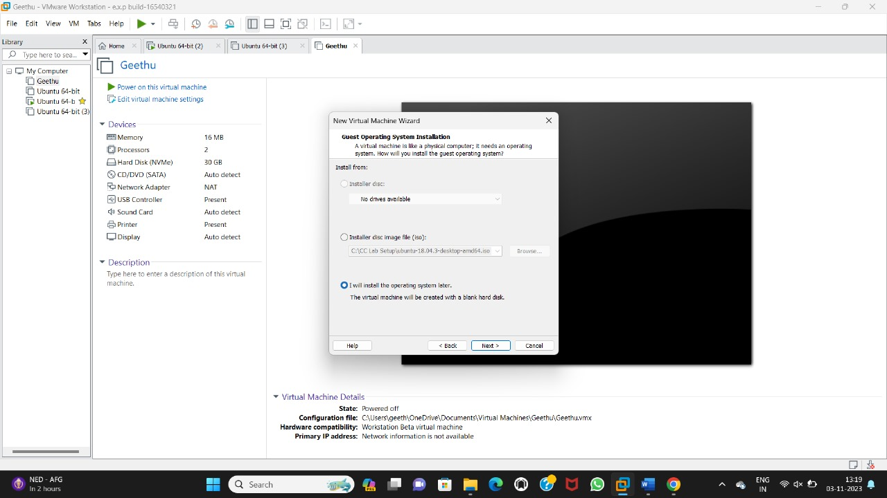

**Step 2:**

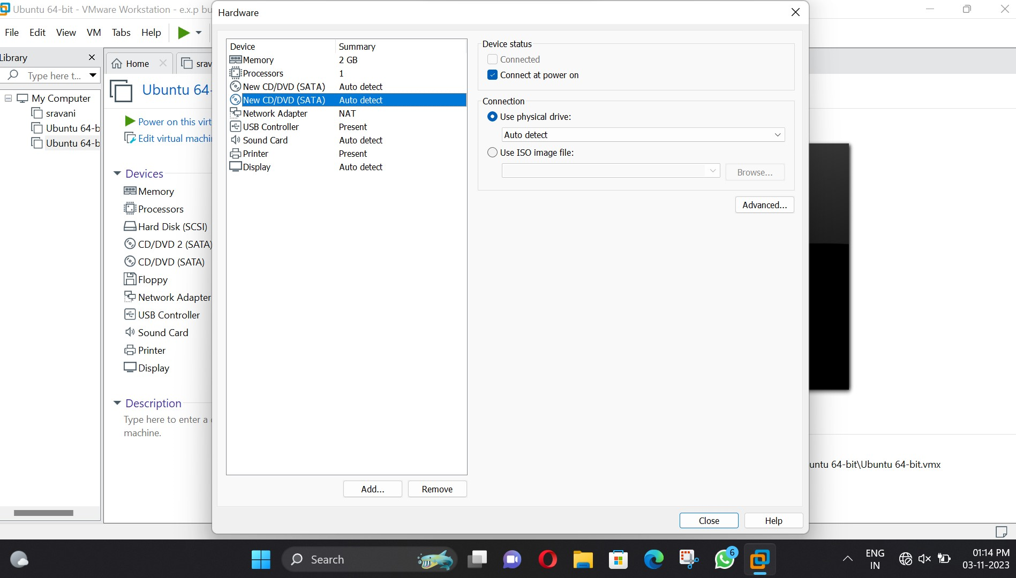

**Step 3:**

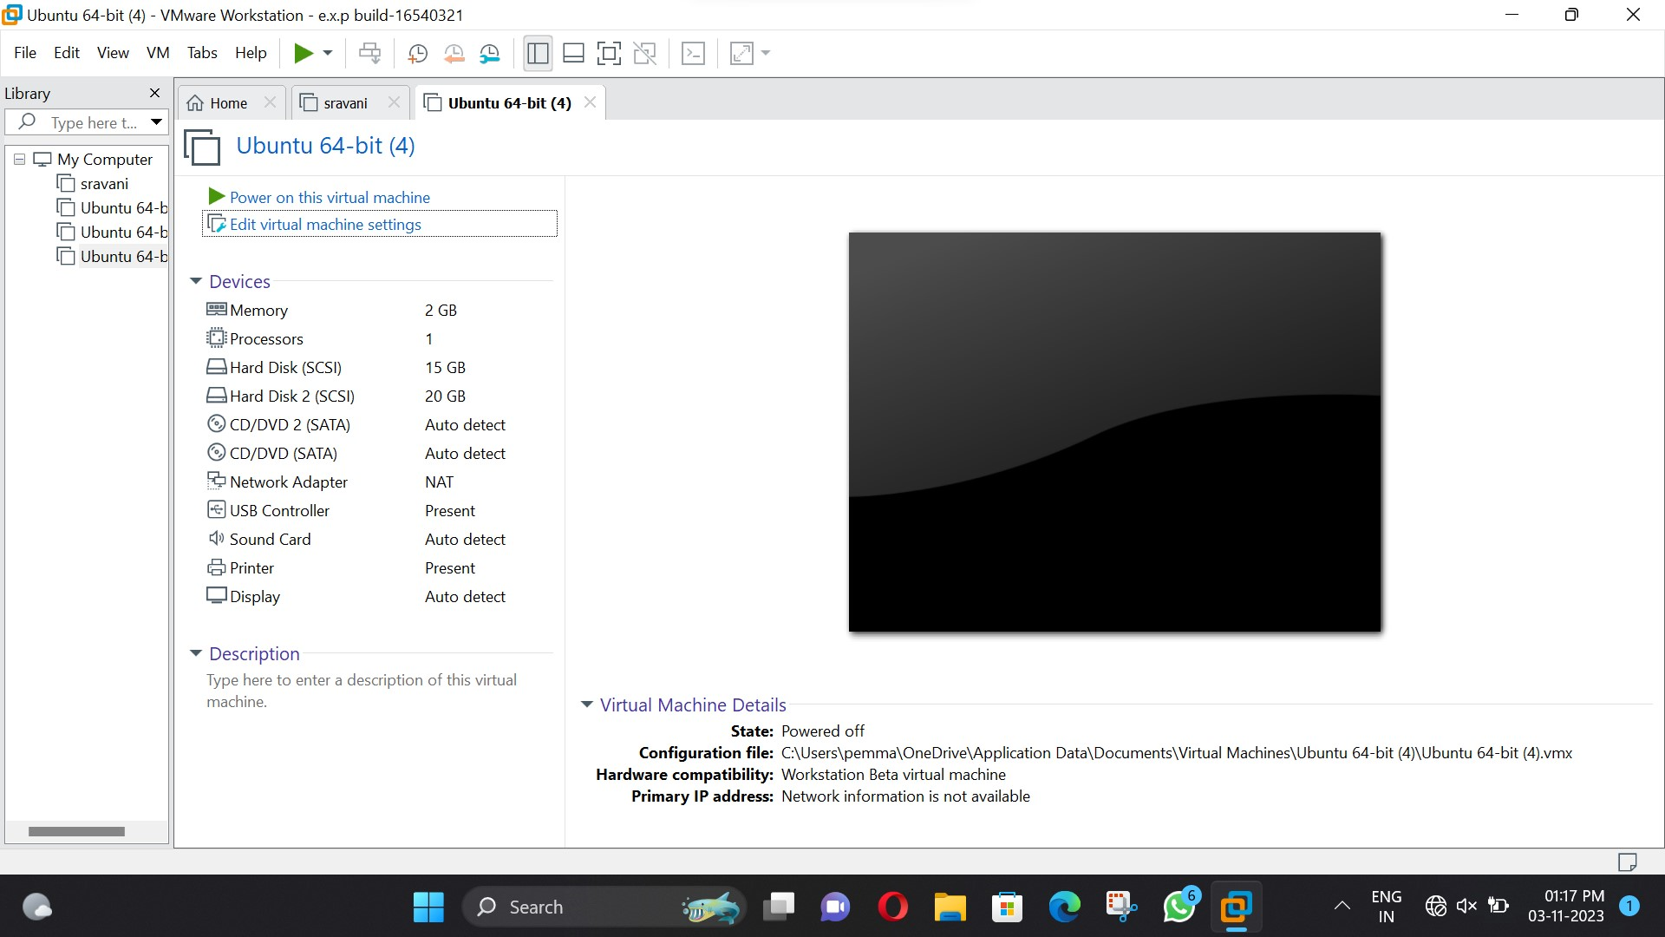

Result:

Thus by using the virtual box hardware compatibility of a VM is created successfully.